E-Commerce Sales & Supply Chain Analysis

Using SQL, Python & Power BI

Abhishek Chitranshi

Objective
- Analyze e-commerce sales data
- Identify delivery delays
- Understand product and category performance
Dataset Description
- Dataset source: Kaggle (Olist E-Commerce)
- Number of records
- Tables used
Tools Used
- Python (Pandas)
- SQL (SQLite)
- Power BI
- GitHub
- Kaggle
Methodology
- Data collected from Kaggle
- Cleaned and merged using Python
- Stored and queried using SQL
- Visualized insights using Power BI
Key Insights
- Electronics category generates highest revenue
- Average delivery time is 8 days
- 12% orders are delayed
Conclusion
- Business impact
- How analysis can help decision-making

Introduction
The rapid growth of e-commerce platforms has generated large volumes of transactional and supply chain data. Analysing this data helps businesses understand customer behaviour, sales performance, and delivery efficiency.
This project focuses on analysing an e-commerce dataset to derive meaningful insights using SQL, Python, and Power BI.
The main objectives of this project are:
- To analyse sales performance of an e-commerce platform.
- To understand product and category-wise revenue.
- To evaluate delivery performance and delays.
- To build an interactive dashboard for business insights.
Dataset Description
Brazilian E-Commerce Public Dataset by Olist
The dataset has information of 100k orders from 2016 to 2018 made at multiple marketplaces in Brazil. Its features allow viewing an order from multiple dimensions: from order status, price, payment and freight performance to customer location, product attributes and finally reviews written by customers. They also released a geolocation dataset that relates Brazilian zip codes to lat/lng coordinates.
This is real commercial data, it has been anonymised, and references to the companies and partners in the review text have been replaced with the names of Game of Thrones great houses.
Context
This dataset was generously provided by Olist, the largest department store in Brazilian marketplaces. Olist connects small businesses from all over Brazil to channels without hassle and with a single contract. Those merchants are able to sell their products through the Olist Store and ship them directly to the customers using Olist logistics partners. See more on our website: www.olist.com
After a customer purchases the product from Olist Store a seller gets notified to fulfill that order. Once the customer receives the product, or the estimated delivery date is due, the customer gets a satisfaction survey by email where he can give a note for the purchase experience and write down some comments.
- path = kagglehub.dataset_download("olistbr/brazilian-ecommerce"

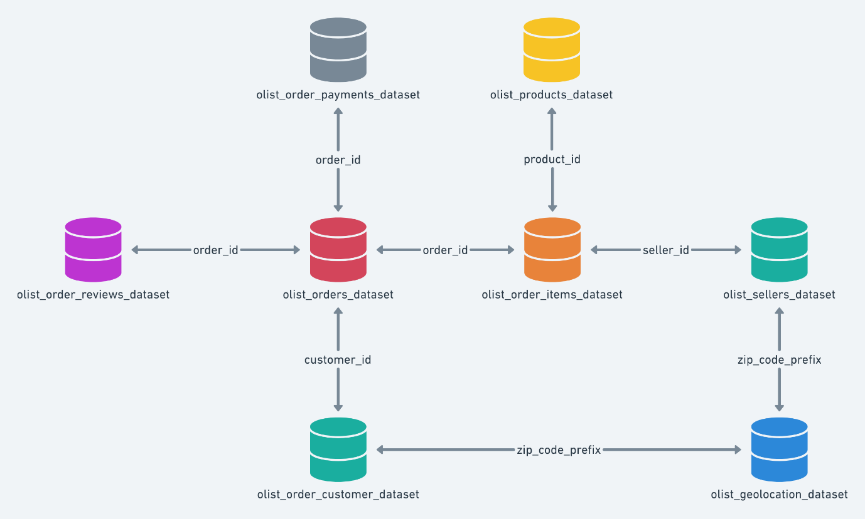
Dataset Schema

  - Cleaning data and creating business column using Python.
Python was used for data loading, cleaning, preprocessing, and dataset preparation before performing SQL analysis and visualization.

Tools & Libraries Used
- Python 3
- Pandas – for data manipulation and analysis
- NumPy – for basic numerical operations
- VS Code – as the development environment

    - Loading the Dataset: the e-commerce datasets were downloaded from Kaggle and loaded into Python using Panda
- orders = pd.read_csv("../Abhishek Project/olist_orders_dataset.csv")
- customers = pd.read_csv("../Abhishek Project/olist_customers_dataset.csv")

    - Merging Orders and Customers Data: Orders and customers datasets were merged using a common key (customer_id) to create a unified dataset for SQL analysis.
orders_customers = pd.merge(
orders,
customers,
on="customer_id",
how="inner" )
1.1.3 Creating Sample Datasets (1000 Rows): To demonstrate SQL JOIN operations and avoid import issues, a 1000-row sample dataset was created.

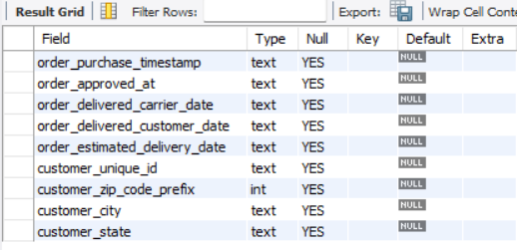
2.1 Sql queries and data interpretation
2.1.1 Database Selection: Query:
USE ecommerce_analysis;

2.1.2 Understanding the Data Structure Query:
DESCRIBE orders_customers_10k;

2.1.3 Total Orders Analysis Query:
Output for 2.1.2
SELECT COUNT(*) AS total_orders
FROM orders_customers_10k;

2.1.4 Unique Customers Analysis Query:
SELECT COUNT(DISTINCT customer_unique_id) AS unique_customers
FROM orders_customers_10k;

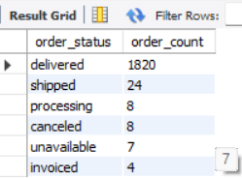
2.1.5 Orders by Status
SELECT order_status, COUNT(*) AS order_count
FROM orders_customers_10k
GROUP BY order_status
ORDER BY order_count DESC;

2.2 SQL Joins

